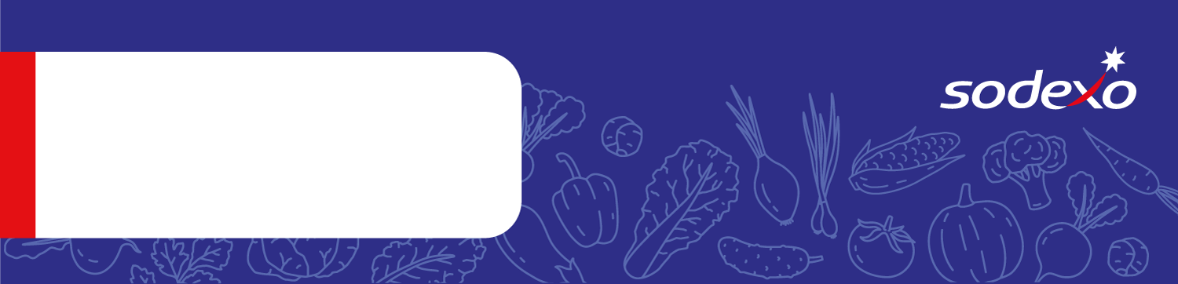
Food Safety Management System
Forms
Information about my child’s special diet
Please fill in this form in BLOCK CAPITALS and return it to your child’s school.
Section A: General details
Child’s full name
Class, form and tutor
Your name
Your relationship to the child
Section B: Declaration
I confirm my child has a food allergy, intolerance or other dietary-related medical condition that needs addressing. The information in this form isn’t about my child’s food preferences.
I agree to information about my child’s allergy and any related doctor’s or registered dietician’s medical assessment being provided to the school’s catering partner Sodexo (including any other relevant personal data, like photographs, if I’ve agreed with the school), solely so they can provide suitable meals for my child.
Parent/ guardian signature |  |  |  | Date
Section C: Allergy details
Does your child have food allergy? If YES, fill in this section. If NO go to Section D.
Please include as much information as possible about your child’s food allergy in the space below. For example:
- Can they tolerate products that say ‘may contain traces’?
- What types of nuts are they allergic to – or should they avoid all nuts?
- Should they avoid all forms of the allergen - or can they tolerate some forms, for example raw, baked or cooked?

If possible, please provide a copy of any relevant medical assessment or confirmation.

Sodexo cannot guarantee the absence of any specific allergen. Our staff will be happy to talk to you about what we do in the kitchen to reduce the risks of allergen cross-contamination.

Allergen |  | Tick if YES |  |  | Additional Information
Celery
Cereals (containing gluten)
Crustaceans
Egg
Milk
Molluscs
Fish
Lupin
Mustard
Nuts
Peanuts
Sesame Seeds
Soya
Sulphur Dioxide (Sulphites)
Other food allergies
If YES please provide as much information as possible about your child’s condition here:

Does your child have an adrenaline auto-injector?
Section D: Other dietary-related conditions
Does your child suffer from a medically diagnosed dietary-related condition (like coeliac disease)?
If YES, please provide as much information as possible about your child’s condition here:

Does your child have any food intolerances? This may or may not be medically diagnosed.
If YES, please provide as much information as possible about your child’s condition here:

