Our School Milk Scheme
Dear Parent or Guardian,

School Milk Services Ltd has been working in partnership with your Local Education Authority since 2001 to deliver fresh milk to schools across the South West.
We provide fresh milk to your school which is free of charge for children under the age of 5, funded by the Department of Health under the Nursery Milk Scheme. Once children reach the age of 5, this funding is withdrawn.
We offer a milk service for children over the age of 5. Each child that is registered will receive a 189ml portion of semi-skimmed milk at the morning break period. The cost of this service is less than £2 per week* and you can pay in either one, two or four instalments across the school year.
Registering
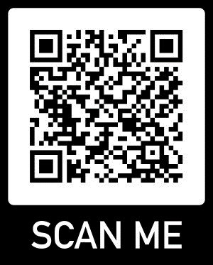
- You can register your child before or after their 5th Birthday by visiting our website at www.schoolmilkservices.co.uk or scanning the QR code on the right:

  - If you are registering before your child’s 5th Birthday, you can either choose to make a payment at the time of registering, or you can ask for a reminder to be sent 4 weeks before your child’s birthday.

  - If you are registering after your child’s 5th Birthday, payment will be requested immediately.

Register by Thursday at 12:00 for your child’s milk to start on the following Monday.
If you have any questions regarding the milk service, please contact us via email at: sales@schoolmilkservices.co.uk or telephone at 01934 510950.
*subject to change
Kind regards,
School Milk Services Ltd

